CS4431 WA Compilers Design

Dr. Sabah Mohammed

Department of Computer Science

Lakehead University

Exercise 2: Parsing C-- Using JFlex and CUP

The purpose of this homework is to write the core of the parser for C- -. You will be using the CUP parser generator to produce a Java class that implements your parser. By the end of this homework you will actually recognize whether a string belongs to the language C- -.

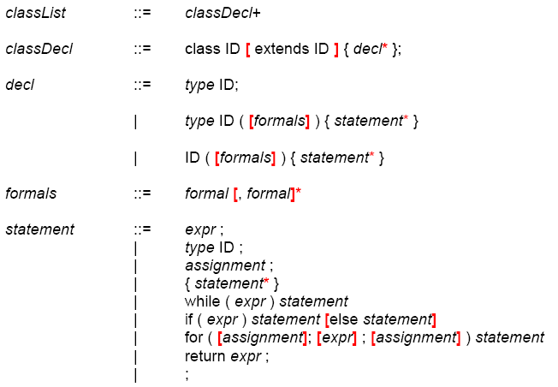

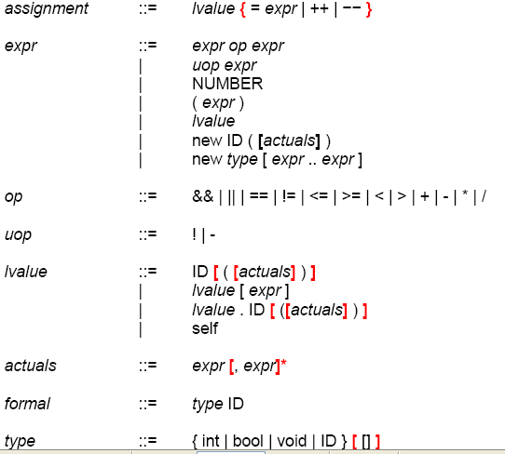

Figure 1: EBNF Grammar for C- -

Develop a Java CUP Specification

Your task is to generate Java CUP for the C—grammar. CUP takes as input a **parser.cup** file that contains the required specifications to tie it to a lexer. I am providing the **lexer code** (feel free to discard our code in favour of your own from Project 1 if you want to). The parser.cup file on the WebCT is missing the grammar where you need to add it. The provided parser.cup may use other provided classes (e.g. SrcLoc). You need to specify your non-terminals and all your grammar productions. Once this is done, you can run CUP to create your parser. If the grammar was an accepted description, you should end-up with a **parser.java** file and CUP should complete its task with no conflicts whatsoever. You can, of course, use/define operator precedences to eliminate conflicts as well as further grammatical rewrites. Remember that you must recognize any syntactically correct C- -programs and nothing else.

The CUP Driver

The **driver** class is already provided to you on the D2L. Once your parser is correct, you should be able to parse a test program. At the moment, the objective for the parser is to determine whether the input belongs to the C- -language and do some rudimentary syntax error reporting.

What to Hand-in

Your solution should include the following:

1. The file parser.cup that contains the grammar implemented in JavaCUP.

2. An MSWord file describing your CUP programming and include some screen shots on the output of the given test files.

3. You submit your Exercise 2 on the due date as a zip archive.

Good Luck.